Date:05.10.2022

**Final Year B. Tech., Sem VII 2022-23**

**Cryptography And Network Security Lab**

**Assignment submission**

**PRN No: 2019BTECS00014**

**Full name: Siddhi Lokhande**

**Batch: B5**

**Assignment: 7**

**Title of assignment: Implementation of AES – Advanced Encryption Standard**

**Title:**

Implementation of Advanced Encryption Standard

**Aim:**

To develop and implement the Advanced Encryption Standard and to do encryption and decryption on the input plaintext

**Theory:**

* AES is an iterative rather than Feistel cipher. It is based on ‘substitution–permutation network’.
* Comprises of a series of linked operations, some of which involve replacing inputs by specific outputs (substitutions) and others involve shuffling bits around (permutations).
* AES performs all its computations on bytes rather than bits. Hence, AES treats the 128 bits of a plaintext block as 16 bytes. These 16 bytes are arranged in four columns and four rows for processing as a matrix
* the number of rounds in AES is variable and depends on the length of the key.
* AES uses 10 rounds for 128-bit keys, 12 rounds for 192-bit keys and 14 rounds for 256-bit keys. Each of these rounds uses a different 128-bit round key

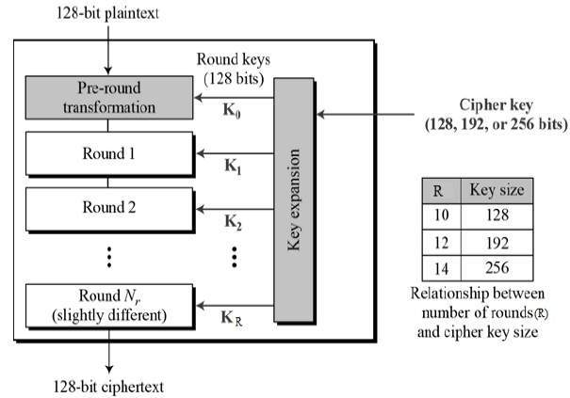

* The features of AES are as follows
* Symmetric key symmetric block cipher
* 128-bit data, 128/192/256-bit keys
* Stronger and faster than Triple-DES
* Provide full specification and design details
* Software implementable in C and Java

**Implementation of Advanced Encryption Standard**

**Code:**

import hashlib

from Crypto import Random

from Crypto.Cipher import AES

from base64 import b64encode, b64decode

class AESCipher(object):

def __init__(self, key):

self.block_size = AES.block_size

self.key = hashlib.sha256(key.encode()).digest()

def encrypt(self, plain_text):

plain_text = self.__pad(plain_text)

iv = Random.new().read(self.block_size)

cipher = AES.new(self.key, AES.MODE_CBC, iv)

encrypted_text = cipher.encrypt(plain_text.encode())

return b64encode(iv, encrypted_text).decode("ütf-8")

def decrypt(self, encrypted_text):

encrypted_text = b64decode(encrypted_text)

iv = encrypted_text[:self.block_size]

cipher = AES.new(self.key , AES.MODE.CBC, iv)

plain_text = cipher.decrypt(encrypted_text[self.block_size:]).decode("utf-8")

return self.__unpad(plain_text)

def __pad(self, plain_text):

number_of_bytes_to_pad = self.block_size - len(plain_text) % self.block_size

ascii_string = chr(number_of_bytes_to_pad)

padding_sgtr = number_of_bytes_to_pad * ascii_string

padded_plain_text = plain_text + padding_str

return padded_plain_text

@staticmethod

def __unpad(plain_text):

last_character = plain_text[len(plain_text) - 1:]

return plain_text[:ord(last_character)]

key = input("Enter Key:")

obj = AESCipher(key)

str = input("Enter input: ")

cipher = obj.encrypt(str)

print(cipher)

plain_text = obj.decrypt(cipher)

print(plain_text)

**Output:**

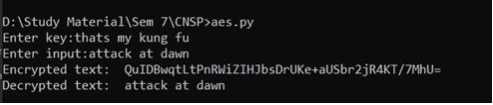

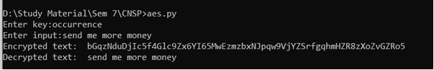

**File Input:**

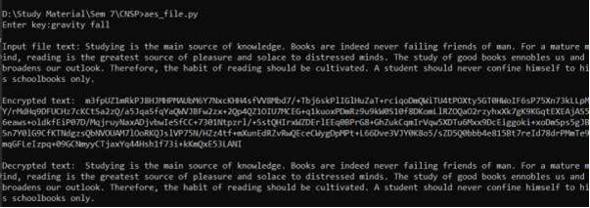

**Conclusion:**

Performed the experiment successfully. Encrypted the data

with the provided key. Output of this encryption is decrypted to match

the plaintext that was inputted by the user as shown in the above

diagram.